**Project Design Phase-I**

**Solution Architecture**

|  |  |
| --- | --- |
| Date | 19 September 2022 |
| Team ID | PNT2022TMID07753 |
| Project Name | News Tracker Application |
| Maximum Marks | 4 Marks |

**Solution Architecture Diagram:**

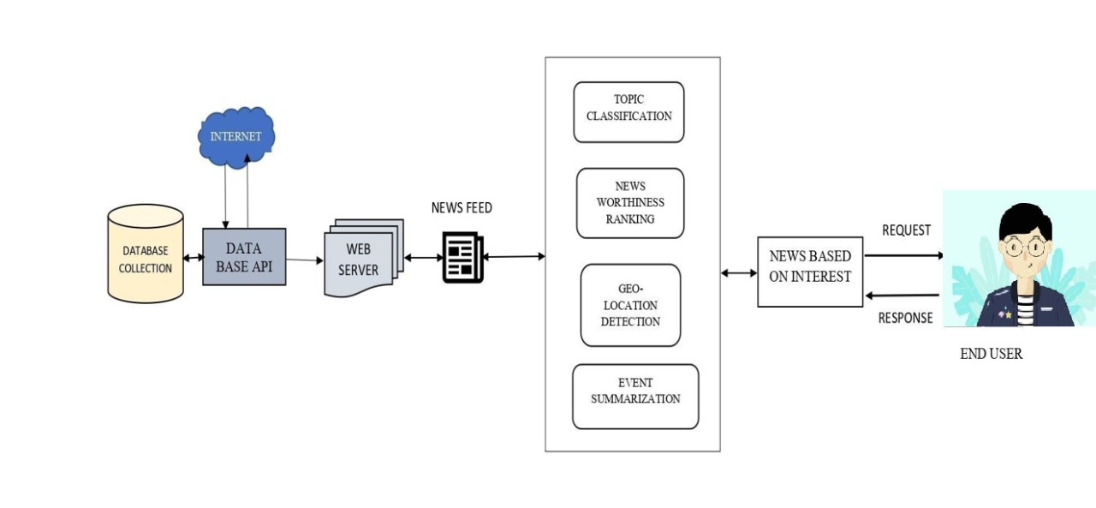

Architecture and data flow of the News tracker application

**Reference –** [**solution architecture**](https://drive.google.com/file/d/1OkmAjfk4CjAvwCLLP8YJIe031JCpAoQE/view?usp=sharing)